Passive Buzzer Module
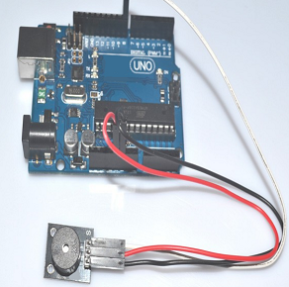
Specification:
Working voltage: 3.5-5.5V
Working current: <25mA
PCB Dimension: 18.5mm x 15mm(L x W)
Feature:
No oscillation source, need square wave (frequency 2K-5K ) to drive.
Sound frequency control, you can make a "do re mi fa sol la si" effect.
Package included:
1 x Standard Passive Buzzer Module
ARDUINO reference source programme:
int buzzer=8;// Set the control the buzzer digital IO pin
void setup()
{
pinMode(buzzer,OUTPUT);// Setting the digital IO pin mode , OUTPUT is Wen out
}
void loop()
{
unsigned char i,j;// Define the variable
while(1)
{
for(i=0;i<80;i++)// Wen a frequency sound
{
digitalWrite(buzzer,HIGH);// Sound
delay(1);//delay 1ms
digitalWrite(buzzer,LOW);//Not sound
delay(1);// delay 1ms
}
for(i=0;i<100;i++)// Wen out another frequency sound
{
digitalWrite(buzzer,HIGH);// Sound
delay(2);//delay 2ms
digitalWrite(buzzer,LOW);// Not sound
delay(2);//delay 2ms
}
}
}
After downloading the program, the buzzer experiments are finish.

